**AI Video Generator**

Table of Contents

Creatify **-** AI-Powered Video Creation Platform 2

vidnoz 4

Pictory 6

vidAU 8

Steve AI 10

TopView 11

GOKU AI 12

AI Video Generation for Product Promotion with Open-Source R&D Results 14

**Analysis on Full creation with API platform suggestions**

***URL to promotion video***

# Creatify **-** AI-Powered Video Creation Platform

https://app.creatify.ai/home - Application link

https://docs.creatify.ai/api-reference/introduction - Documentation and Pricing

**Key Features:**

* **Manual Upload Option:** Users can manually upload content for video creation.
* **Promotional Content Addition:** The platform allows users to add promotional details to videos.
* **URL Analysis**: Extracts and analyzes information from a given URL to generate video content.
* **Easy Customizable Video Settings**:
  + Choose the target platform
  + Select aspect ratio
  + Adjust video duration
  + Pick a language (supports Chinese)
  + Define target audience
* **AI-Suggested Scripts**:
  + Users can choose AI-generated scripts
  + Option to generate more script variations
  + Edit scripts as needed or create a custom script from scratch
* **Script Limit**: Generates scripts with a maximum of 3,600 characters.
* **Avatar Selection**:
  + Choose between realistic, styled, and custom avatars
  + Option to create videos with or without avatars

* **Watermark and Credit System**:
  + Videos without a watermark require 10 credits
  + Videos with a watermark require 5 credits
* **Video Suggestions**: Provides 15 AI-suggested videos for promotional purposes, featuring:
  + Human-like avatars
  + Videos with and without avatars

**PRICING**

Note: Creatify primarily supports **Amazon, eBay, Etsy, and Shopify** for generating video ads from product URLs. However, it successfully extracted information from Flipkart, Meesho as well. If an unsupported platform is used, results may vary. In such cases, manual input can help enhance video creation.

**Supported languages**

Creatify supports 29 languages to cater to global audience: English, Hindi, Portuguese, French, German, Japanese, Chinese, Spanish, Korean, Indonesian, Italian, Arabic, Bulgarian, Czech, Danish, Dutch, Greek, Finnish, Croatian, Malay, Romanian, Slovak, Swedish, Ukrainian, Russian, Tamil, Tagalog, Turkish, Polish.

# vidnoz

https://aiapp.vidnoz.com/video/index.html?openTab=urltovideo – our proposal suggestion

<https://www.vidnoz.com/url-to-video.html> - url to video

Vidnoz is an AI-powered video generation tool that allows users to create videos from URLs. It supports Amazon and Playstore product links, extracting relevant details to generate video scripts and content.

**Key Features:**

* **Supported Platforms:** Only supports Amazon and Play store.
* **Data Extraction:** Extracts Amazon product details.
* **Media Support:** Can be able to add media photos
* **Target Audience:** Can be able to choose Target audience
* **Language Support:** Video language supports Chinese (Mandarin)
* **Video Size:** Video platform size supports 9:16, 16:9
* **Script Generation:** Creates video scripts automatically
* **Processing Time:** Generating time is quite long
* **Manual Input:** Can’t be able to upload manual information.
* **Video Suggestions:** Generates one video per script, no multiple video variations.
* **Limitations:** No manual input, slow generation time, and no multiple video suggestions.
* **Pricing:** Can create sample videos via application for free, but API usage requires payment.

**Pricing**

Vidnoz AI supports Chinese (Mandarin) as one of its languages

# Pictory

<https://app.pictory.ai/storyboard/articletovideo> - application link

Pictory AI is an AI-powered video creation platform designed to transform text-based content into engaging videos, making it a valuable tool for product promotion.

**Key Features:**

* **AI-Powered Script-to-Video Conversion** – Converts text (e.g., blog posts, product descriptions, or scripts) into engaging videos automatically.
* **E-commerce Product Detail Extraction** – Capable of extracting product details from e-commerce pages, making it useful for promotional videos.
* **Scene-wise AI Summarization & Editing** – Automatically generates summaries for scenes, allowing users to **edit and rephrase** scenes manually.
* **Manual Customization** – Users can **add backgrounds, audio, and upload images** while customizing text styles.
* **Video Duration & Orientation Adjustments** – Allows **scene-wise duration edits** and supports **portrait & landscape** modes for various platforms.
* **Scene Editing with Adjustable Durations** – Users can **edit scenes** but might have **limited control over exact video durations**.
* **Promotional Content Integration** – Supports **manual upload of promotional details** and content.
* **Large Media Library** – Access to over 3 million royalty-free video clips, images, and 15,000+ music tracks.
* **14-Day Free Trial** – Provides a risk-free trial before committing to a paid plan.

**Limitations:**

* **Wireframe Suggestions Lack Accuracy** – AI-generated video structures may **not always align** with user expectations.
* **Limited Precision in Scene Duration Adjustments** – While you can edit **scene durations**, exact control over **overall video timing** may be restricted.
* **Dependent on AI Selection** – Auto-generated summaries and media may require **manual correction** to ensure accuracy.
* **Customization Limits** – While users can add content, some **advanced editing** features (e.g., in-depth animations, transitions) are **not as flexible** as professional editing tools.

**Pricing & Suitability for Product Promotions:**

* **14-day Free Trial** to test features.
* Paid plans start from **$19/month for single user**, but higher tiers unlock **premium assets & team collaboration features**.
* Best suited for **quick product videos, ads, and social media content** but **not ideal for highly detailed, professionally animated videos**.

**Pricing**

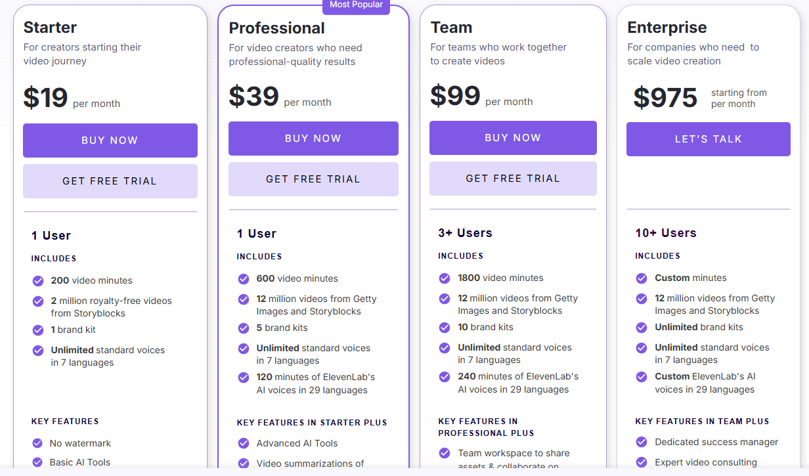

Pricing link: <https://pictory.ai/pricing?el=5000&htrafficsource=pictoryblog#tve-jump-19487f346da>

Pictory AI has expanded its language support to include Chinese, enhancing its accessibility for a broader audience.

**Language Support:** **Chinese Language -** Pictory AI now supports Chinese for voiceovers and subtitles, allowing users to create content tailored for Chinese-speaking audiences.

# vidAU

<https://app.vidau.ai/site/> - application link

<https://document.vidau.ai/vidauai-api/api-documentation/openapi> - documentation link

VidAU.ai provides a tool that converts product links into video ads. By inputting your product URL, the AI generates creative, professional, high-quality video ads tailored to our needs. It's compatible with platforms like Amazon, Shopify, and Etsy

**Key features**

* **No Free Trial for Generating Videos**: While VidAU offers a free plan with limited features, generating videos without watermarks requires a paid subscription.
* **Adjustable Ratio and Video Length**: Customization options for aspect ratios and video lengths are available but may be limited in lower-tier plans.
* **Extraction Limitations with Unsupported Platforms:** VidAU excels with supported platforms like Amazon, Shopify, and Etsy. However, extracting accurate information from unsupported platforms may present challenges.
* **Credit-Based Pricing Model:** VidAU operates on a credit system, where different features consume varying amounts of credits. This requires users to monitor their credit usage to avoid additional costs.
* **Potential Learning Curve:** New users may need time to fully explore and utilize all advanced features effectively
* Can’t be able to download video asking for upgrade in vidau ai

**Supported platforms for extraction:**

Note: vidau primarily supports **Amazon, eBay, Etsy, and Shopify** for generating video ads from product URLs. However, it successfully extracted information from Flipkart, Meesho as well. If an unsupported platform is used, results may vary.

**Pricing**

**Language support**: VidAU.ai supports Chinese among its multilingual capabilities. Its AI Voice Cloning feature supports 49 languages, including Chinese. Additionally, VidAU's AI Video Translator can translate videos into over 120 languages, including Mandarin.

# Steve AI

Link - <https://app.steve.ai/dashboard>

Pricing link - <https://app.steve.ai/pricing>

Steve AI is an AI-driven video creation platform that enables users to produce professional videos and animations swiftly. It offers various features tailored for different content creation needs.

* **Limited Platform Support:** Doesn’t support other platforms like Flipkart, meesho supports amazon
* **Less Accurate Script & Scene Generation**: The extraction and script generation features are not very precise, affecting scene quality.
* **Text Limitations:** Each scene can only accommodate **200 characters** of text, restricting longer dialogues or descriptions.
* **Topic-Based Video Generation:** Users can specify the type of video (e.g., animation, GenAI, talking head, etc.).
* **Voiceover and Music Addition:** Allows users to add custom voiceovers and background music to their generated videos.
* Can’t be able to download video asking for upgrade steve ai

**Pricing**

**Language support:** In Steve.AI, can create video in six languages: English, French, German, Italian, Portuguese and Spanish. **Steve AI** does not currently support **Chinese** for video script generation, subtitles, or voiceovers. It primarily supports **English** and a few other widely used languages.

# TopView

Link – <https://www.topview.ai/dashboard/home>

Pricing link - <https://www.topview.ai/pricing>

**Key features**

* **AI-Powered Video Generation:** Converts product links and media assets into promotional videos with minimal effort.
* **Script Generation:** Uses GPT-4o to create compelling scripts; users can also write their own scripts (max limit: 5000 characters).
* **Target Audience & Video Length Adjustment:** Allows customization of the video’s length and intended audience.
* **Platform Support:** Extracts information from URLs of supported platforms:
  + **Amazon, eBay, Shopify, Etsy, AliExpress, TikTok Shop, Apple App Store, Google Play Store.**
  + **Note:** If you provide links from platforms outside this list, the AI can still extract information, but the accuracy and completeness may not be as reliable.
* **Analysis Speed:** Takes a longer time to analyse and generate videos compared to some competitors.

**Pricing:**

* **Language Support:** Supports multiple languages, including **Traditional Chinese** and other specified languages in China.

# GOKU AI

Link: <https://gokuai.org/>

Goku AI is an advanced video generation model developed by ByteDance, designed to create high-quality videos from text prompts and animate still images. It utilizes a Rectified Flow Transformer (RFT) architecture, setting it apart from traditional diffusion models, and is capable of producing realistic human-centric videos, making it particularly useful for advertising and social media content.

**Pricing:** Goku AI offers a range of pricing plans to accommodate different user needs:

* **Free Plan:** Includes 3 credits, allowing users to explore basic features at no cost.
* **Starter Plan:** Priced at $9.90 for 20 credits, suitable for small projects.
* **Pro Plan:** Available for $49, providing 200 credits and priority in the generation queue.
* **Premium Plan:** At $99, offers 800 credits with additional benefits like no watermarks and extended validity

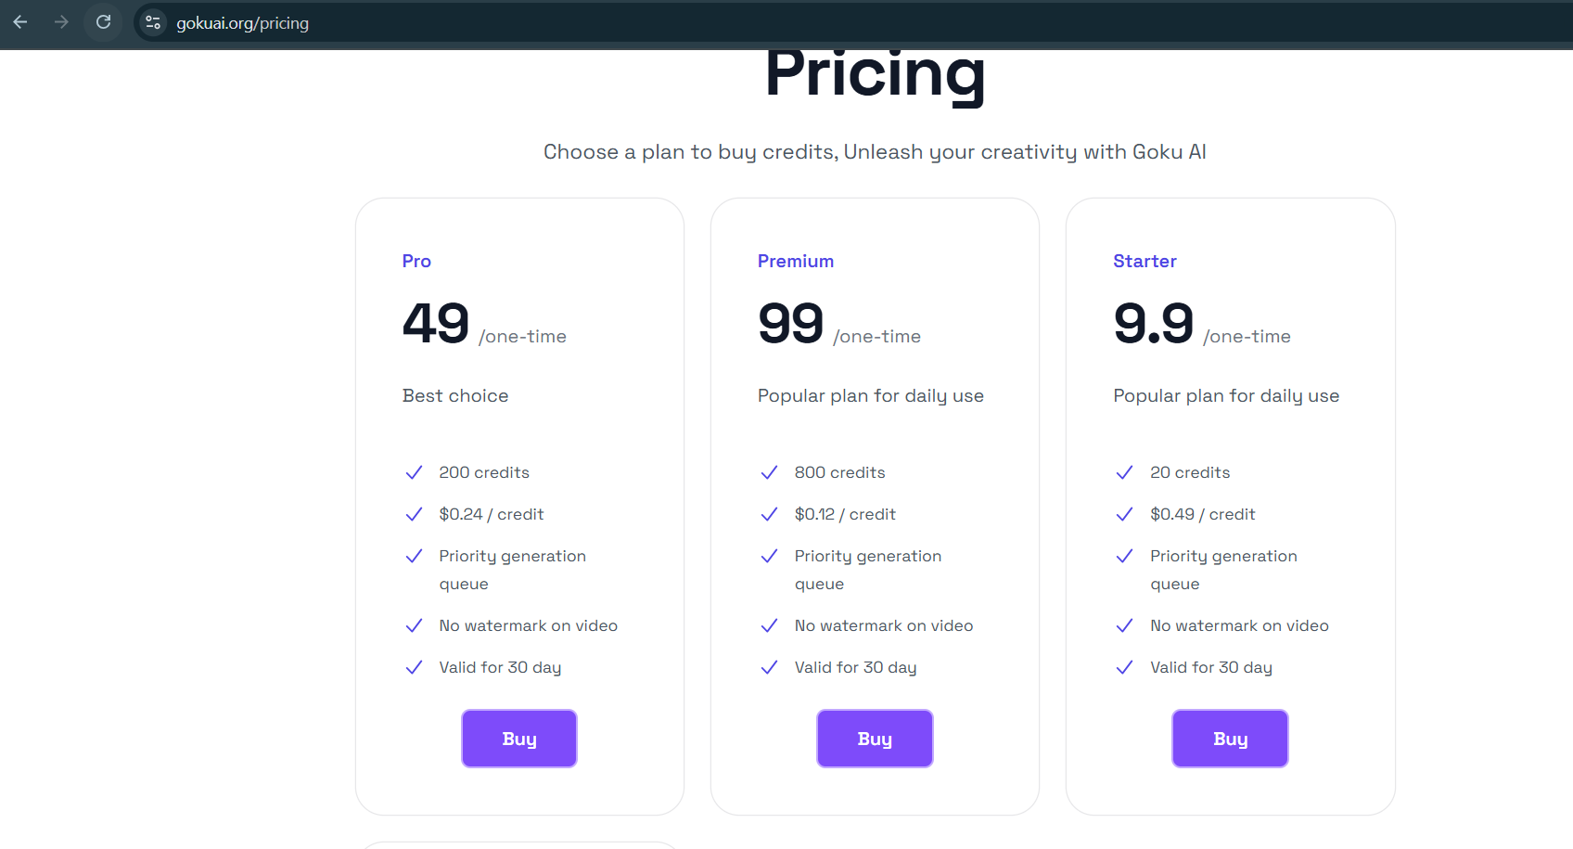

**Language**: Goku AI supports the Chinese language. Users can input text prompts in Chinese to generate corresponding videos or images.

**Inference:**

The basic version does not provide a proper response. The Pro version, which includes 3 credits for image-to-video generation, attempts to produce a customized result but encounters errors.

Currently, Goku AI is not a fully stable version, as users have reported inconsistencies and errors, especially in customized video generation.

# AI Video Generation for Product Promotion with Open-Source R&D Results

In addition to exploring API capabilities and key features, conducted research and development (R&D) on building a custom AI-powered video generation for product promotion pipeline using open-source tools.

**Overview of the AI Video Generation Process**

The approach involved integrating multiple APIs for various stages of video creation, including:

1. **Product Details Extraction:** APIs were used to fetch product-related information.
2. **Script Generation:** AI models generated both the spoken script and narration for the video.
3. **Voice Synthesis:** Speech was generated using **Edge TTS** to align with the script.
4. **Video Assembly:** The final video was compiled using pre-set configurations for animation and transitions.

**Web Scraping for Product Details**

Traditional web scraping methods using **Beautiful Soup** and **Selenium** were employed to extract product names and descriptions. However, video and image extraction from product pages was not feasible through these techniques and with website restrictions.

**AI-Powered Script and Voice Generation**

* **Script Generation:** OpenAI models were used to generate structured scripts for video narration.
* **Voice Generation:** Edge TTS successfully converted the generated scripts into speech.

**Challenges in Video Generation**

1. **Experimentation with Open-Source Models:**
   * Diffusers-based models from **Hugging Face**, **Pexels AI**, **DALL·E**, and **Sora** were tested for video generation.
   * These models did not function optimally in a local environment due to **high storage and processing requirements**.
2. **Custom Video Generation Limitations:**
   * The process involved generating individual frames from scripts and assembling them into a video.
   * This approach required **significant computational power**, making real-time or efficient generation impractical.
3. **Performance of Goku AI:**
   * For **generalized image-to-video** tasks based on prompts, **Goku AI** performed reasonably well.
   * However, it lacked accuracy and customization capabilities for **specific, user-defined video generation tasks**.

**Conclusion: Need for a Paid API Solution**

Based on the R&D results, **open-source AI video generation models are not suitable for highly customized requirements** due to:

* **Inaccuracy in custom video generation**
* **Long processing times and high storage needs**
* **Limited control over video quality and transitions**

To meet client requirements effectively, we recommend **moving to a paid AI video generation API** that offers:

* **Scalability and faster processing**
* **More accurate and customizable video generation**
* **Advanced settings for seamless integration**

Paid solutions will ensure efficiency, accuracy, and better control over video creation, aligning with the client's key needs.